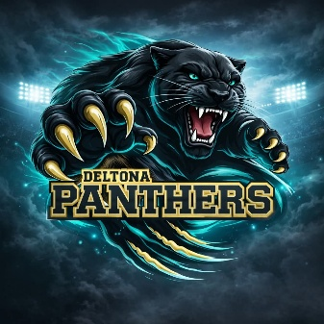

DELTONA PANTHERS TACKLE FOOTBALL
& CHEERLEADING ASSOCIATION, INC
P.O. Box 4026
Enterprise, FL 32725

The Deltona Panthers Youth Tackle & Cheerleading Association is a proud 501(c)(3) nonprofit dedicated to empowering young athletes across Volusia County, Florida. Entirely volunteer-run — from coaches to board members — our organization thrives on the commitment of community leaders and the generosity of donors like you.
Last year, more than 200 children from Deltona, Orange City, and Debary participated in our football and cheerleading programs. We welcome children ages 5–14 for football and 5–16 for cheerleading, offering them not only athletic opportunities but also a safe, structured environment that builds character, discipline, and academic excellence.
Our Mission
Through football and cheer, we instill values that last a lifetime:
- Academic achievement supported by mentorship and accountability
- Teamwork and resilience developed through practice and competition
- Character and leadership nurtured by dedicated volunteers and board members
We believe every child deserves the chance to grow into a confident, responsible young adult — and our programs provide the tools to make that possible.
Why Your Support Matters
Operating a youth sports league requires significant resources. Sponsorships and donations directly fund:
- Safe, high-quality uniforms and protective equipment
- Training and safety gear for both football and cheerleading
- Referee fees to ensure fair play
- Concession supplies that sustain our events and community gatherings
Every dollar you contribute helps us remove financial barriers, ensuring that no child is turned away due to cost.
Sponsorship Opportunities
We offer multiple sponsorship levels, each with tailored benefits and advertising opportunities for your business or organization. If a set level isn’t feasible, we welcome contributions of any amount — including in-kind goods and services. Your support will be recognized and celebrated within our community.
Join Us in Building the Future
By investing in the Deltona Panthers, you are investing in the future of our youth, our community, and the values that strengthen society. Together, we can continue to expand opportunities for children, foster academic and athletic excellence, and inspire the next generation of leaders.
For questions or to discuss sponsorship opportunities, please contact:
Amanda Hall
Fundraising Director
📞 386-275-6122
✉️ fundraisingdeltonapanthers@gmail.com
DeltonaPanthers.com
https://leagues.bluesombrero.com/deltonapanthersyouthfootballandcheerleadingassociationinc

Scan the QR code to visit our website.
Deltona Panthers Youth Tackle & Cheerleading Association
501(c)(3) Nonprofit Organization | IRS Tax ID #264142547

